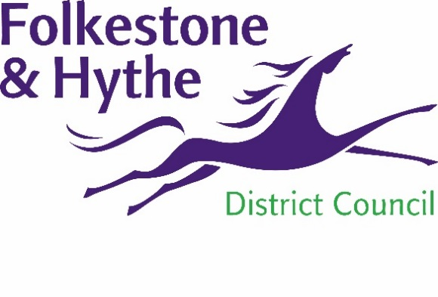
NEWS RELEASE

21 November 2019

COUNCIL AGREES FUTURE FUNDING FOR OTTERPOOL PARK PROJECT

Future funding for Otterpool Park, the proposed garden town, has been earmarked by Folkestone & Hythe district councillors at meetings held yesterday (20 November 2019).
The request for funding of £100 million was put before Cabinet and Full Council to progress the project. The amount is substantial in size so that it can be drawn down from over a period of five years for investment into the Otterpool scheme.
A spokesperson for Folkestone & Hythe District Council said: “The Otterpool Park garden town will mean that we can meet our housing needs in a sustainable way. By ensuring we have a say in future housing development we can push for high quality homes that have appropriate infrastructure to support them.
“Otterpool Park has the potential to be an exemplar project – a true garden town, built from scratch - with over 50% of the development designated as green space. Anchored around the centrepiece of Westenhanger Castle this new town will create job opportunities, schools, shops, medical facilities and other amenities that a vibrant and sustainable new community needs, both now and in the future.”
Subject to planning approval Otterpool Park will be delivered in phases over the next 30 years.
To find out more please visit folkestone-hythe.gov.uk/otterpoolpark
ENDS
Notes to Editors
- Otterpool Park is a proposal for a new community of up to 10,000 homes with 50% of the development designated as green space. An outline planning application for the first 8,500 homes was submitted in February 2019.
For more information, please email communications@folkestone-hythe.gov.uk

Follow us on Facebook: @FolkestoneandHytheDC
Follow us on Twitter: @fstonehythedc
Follow us on Instagram: @folkestonehythedc
Follow us on LinkedIn: Folkestone & Hythe District Council

